Ghana Cyber Act Compliance for Log360
Strengthen data protection and meet Ghana Cyber Act compliance with Log360.
Region: Ghana | Type: Data Privacy, Critical Infrastructure, Incident Management | Category: Compliance | Pricing: Free

Overview
The Ghana Cyber Act compliance extension in Log360 helps organizations meet the Ghana Cybersecurity Act, 2020 (Act 1038), Ghana's national cybersecurity law mandating 24-hour incident reporting, critical information infrastructure protection, and cybersecurity service provider licensing by providing centralized log management, real-time threat detection, and audit trail capabilities. The platform supports Ghana Cyber Act requirements for governance, CII protection, incident reporting, access control, security audits, data protection, network security, and digital forensics.
For Governance and Regulatory Compliance, Log360 tracks AD policy changes, GPO configurations, user and group auditing, and OU management to evidence compliance. To address Critical Information Infrastructure Protection, the platform monitors Windows threat detection, FireEye reports, network device security, policy management, and network attack logs for CII protection. The extension also supports Incident Reporting and CERT Operations by providing capabilities that delivers real-time threat detection via FireEye, Trend Micro, McAfee, Windows threat reports, and network attack monitoring for CERT coordination.

Key Features
- Access Control and Authentication: Log360 captures Windows and Unix logon/failed logon events, AD logon activity, and MFA authentication records.
- Security Audits and Compliance Standards: Log360 aggregates Windows system events, EventLog data, database audit logs, and vulnerability scanner reports for audit support.
- Data Protection and Privacy: Log360 tracks file changes, Windows registry modifications, USB storage auditing, Exchange mailbox audit logging, and Unix removable disk activity.
- Network Security and Perimeter Defense: Log360 audits network device logon, account management, policy changes, attack reports, and firewall configurations across network infrastructure.
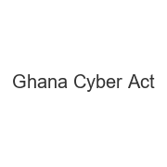
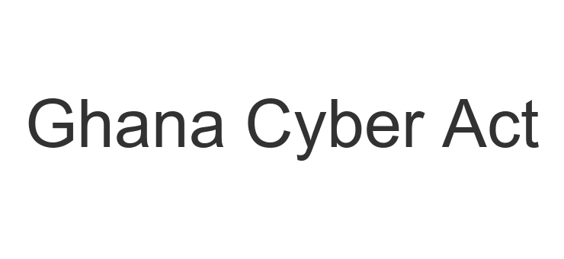
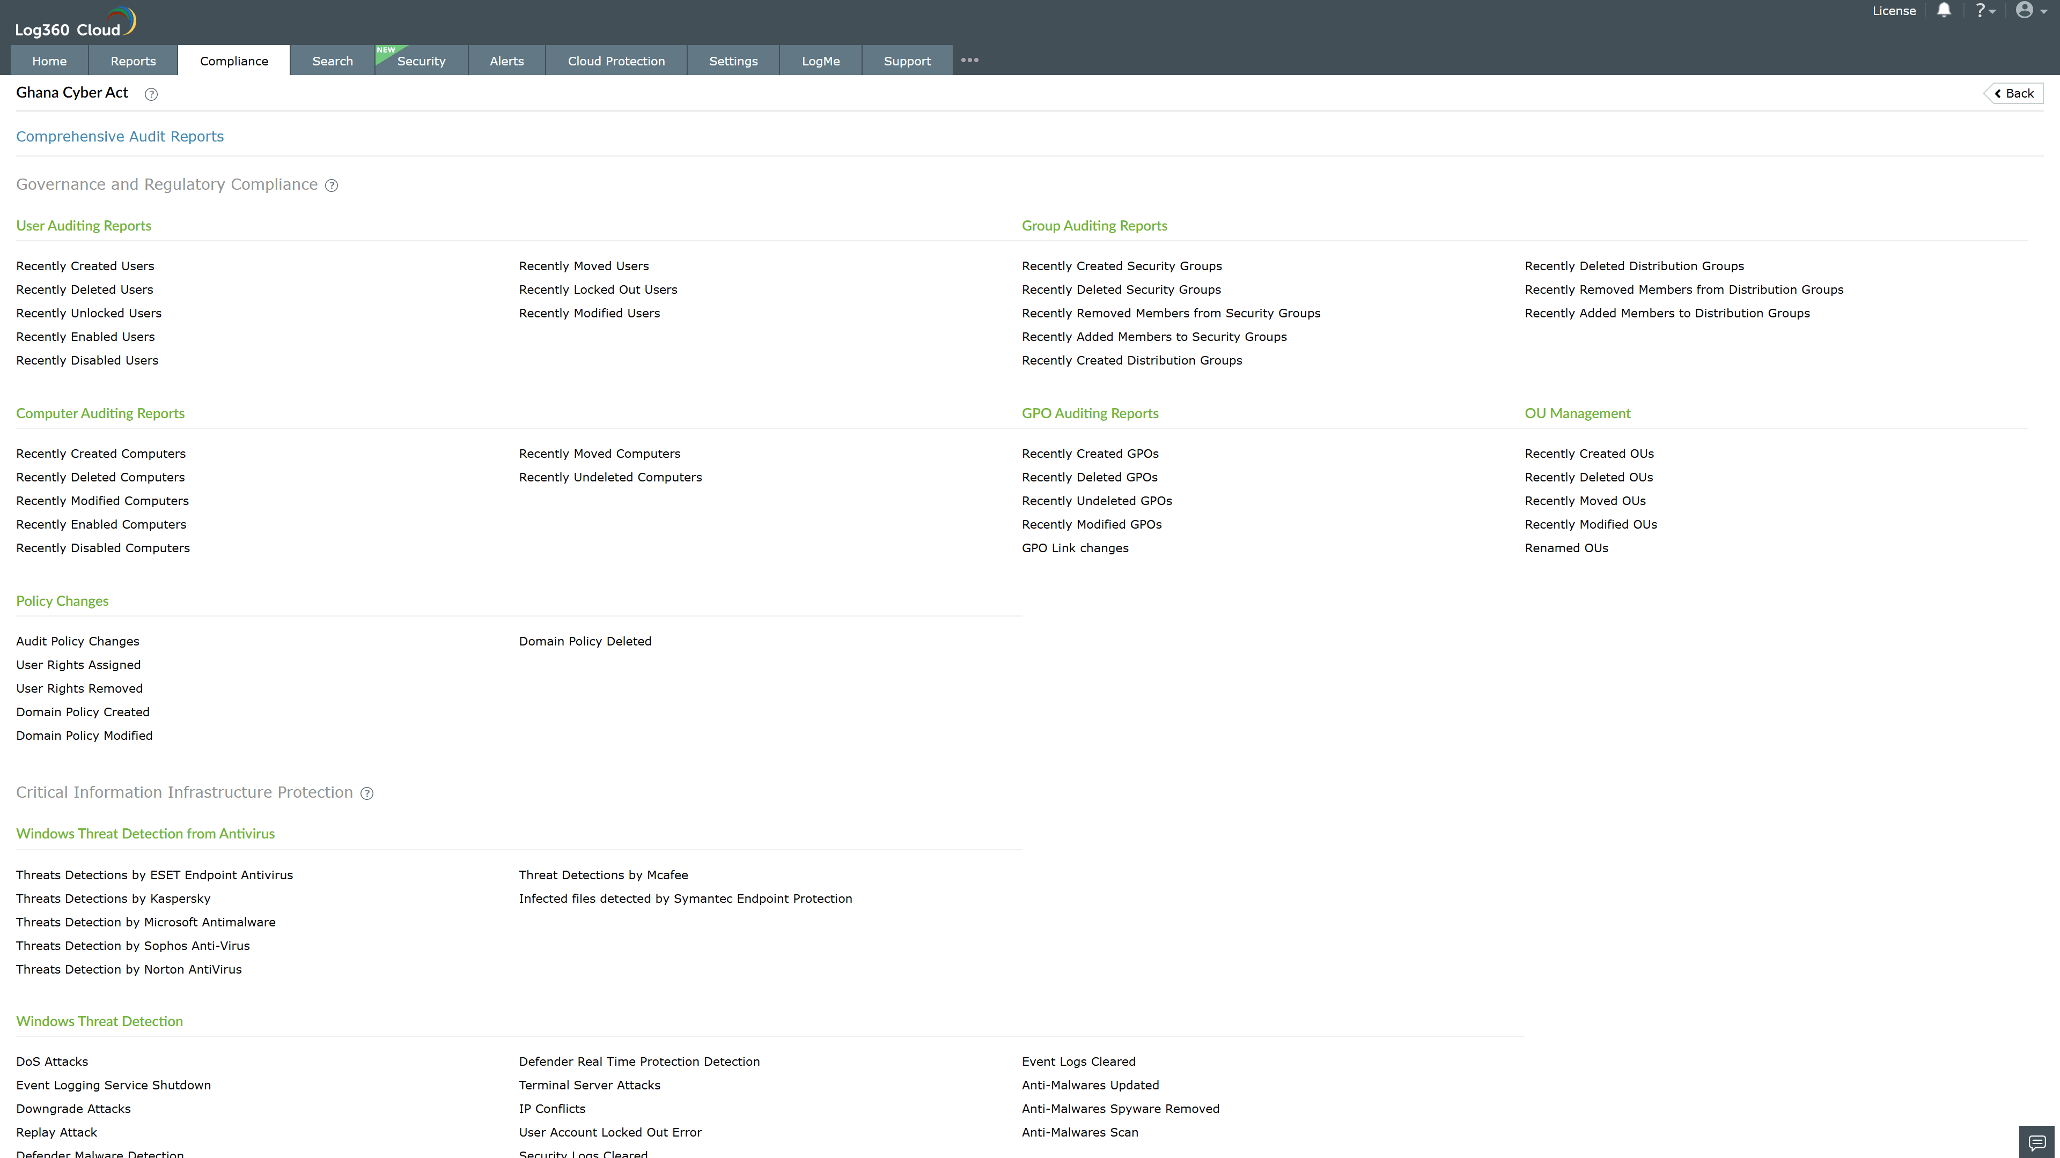
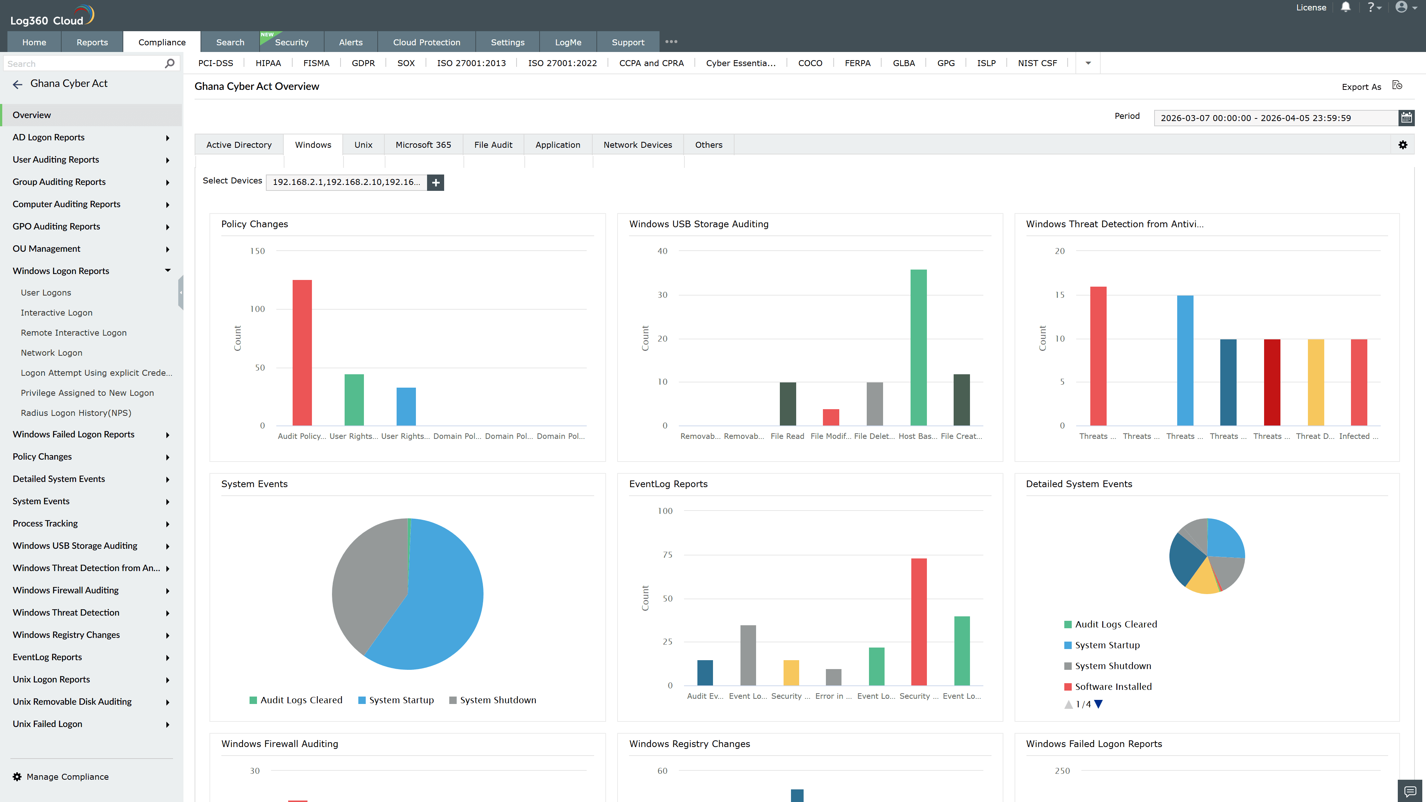
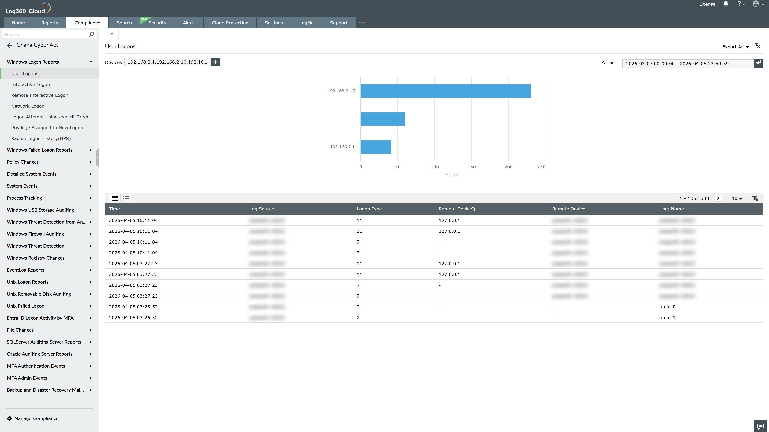
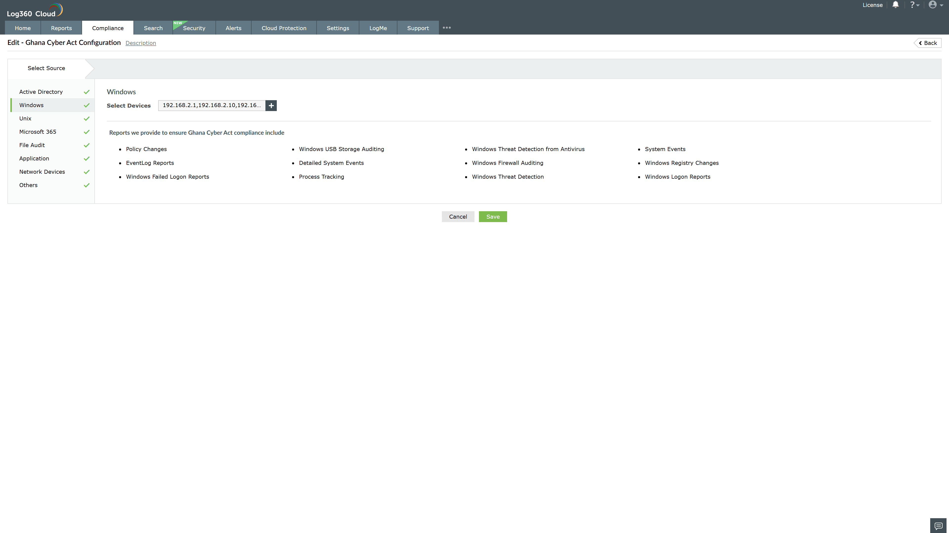
Valid Submission : Yes
Supported Editions : Free, Basic, Standard, Professional, MSSP
Help Document : https://www.manageengine.com/log-management/help/integrations/compliance-extensions.html
Help Video : Not provided
Tags : Log360, Compliance, Privacy monitoring, Data privacy, Regulatory compliance
Supported DCs : US, IN, JP, CA, AU, UK and EU
Privacy Policy:
Terms of Service:
Release Notes:
Predefined reports for the Ghana Cyber Act.

